FOOD APPLICATION ONLY
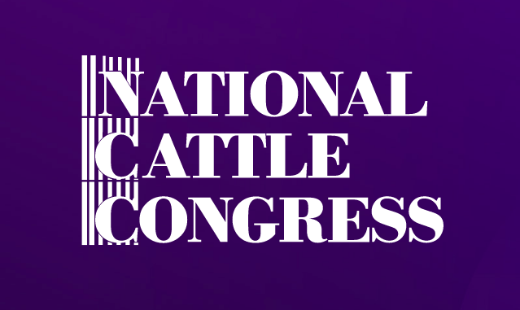
National Cattle Congress Fair
September 16-20, 2020

COMPANY NAME:

CONTACT:

MAILING ADDRESS:

PHONE #:

EMAIL:

Exhibit Purpose – Products of services to be displayed or a list of items to be sold. All food MUST be approved by Concessions Manager. NCC reserves the right to allow certain items to be sold.
Application MUST include photo of Booth/Trailer/Display.

Size of space needed: X

Please list references from two fairs or trade in which you have recently participated in:
- Event Name 2. Event Name
Coordinator Coordinator
Phone Number Phone Number

Applicant agrees to abide with all National Cattle Congress Fair rules and regulations, and that the information in this application form is complete and true, to the best of their knowledge.

Signature_____________________________________________________ Date_____________________

Important Notice
Please submit your application to karen@nationalcattlecongress.com. A NCC representative will contact to you if your booth is accepted. A $25.00 fee will be applied to all applications and all paperwork that require printing, copying, faxing or mailing.

National Cattle Congress
PO Box 298 - Waterloo, IA 50704
Tel. # 319.232.5801

